PR2 Kinect2 upgrade instruction

Revision History

Version | Date | Description | Author
0.1 | 1-12-2016 | PR2 Kinect2 upgrade instruction | Moe Sepahi

Contents

Revision History 2
Contents 3
Overview 4
IMPORTANT: 4
INTRODUCTION: 4
SCOPE: 4
Parts List 5
Assembly Instruction-Page1 6
Assembly Instruction Page2 7
Assembly Instruction Page3 8
Assembly Instruction Page4 9
Assembly Instruction Page5 10

Overview

IMPORTANT:
This documentation contains information proprietary and confidential to Clearpath Robotics. Any disclosure, use, publication, transmission or duplication of this documentation or any of the information contained herein for other than the specific purpose for which it was disclosed is expressly prohibited.

INTRODUCTION:

This document is prepared by Clearpath PR2 team .it outlines the steps for installation Intel NUC and Kenict2 sensor on existing PR2,
Ubuntu operating system plus all software application required for Kinect2 Sensor already installed on Intel NUC computer.

SCOPE:

The instruction for Kinect2 Upgrade apply to PR2 Robotics team and PR2 repair Technicians. Following all steps are mandatory, any step that is not followed may result in one or more of the following consequences; damage on PR2’s parts, Intel NUC or Kinect2 sensor.

Parts List

Inside your upgrade package you can find Intel NUC computer , Kinect2 Sensor and Head Cap :

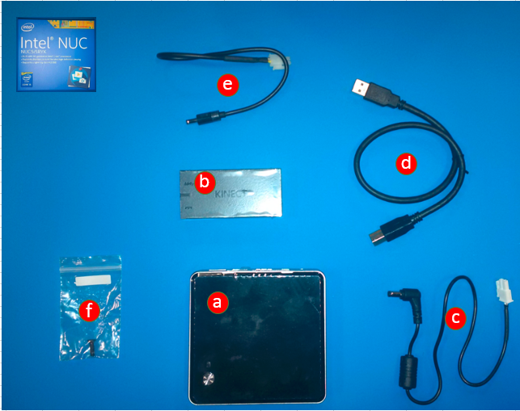

- Inside NUC BOX
  - Intel NUC computer
  - Kinect2 interface
  - NUC Power cable
  - USB-3 cable
  - Kinect2 Power cable
  - M4 screw
- Kinect2 Sensor plus Sensor adaptor
- Black Cap cover

Assembly Instruction-Page1

Steps for installing PR2 Kinect2 on the PR2 head:
- Remove the existing Kinect bracket on the top of the head
  - Use 4mm Allen key and remove the 8 screws
- Install the Kinect2 Sensor Hardware on the top:
  - Close all 8 screws on the top of the head using 4mm bit with the 2.0 Nm torque wrench,: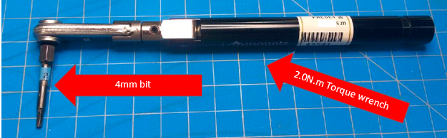
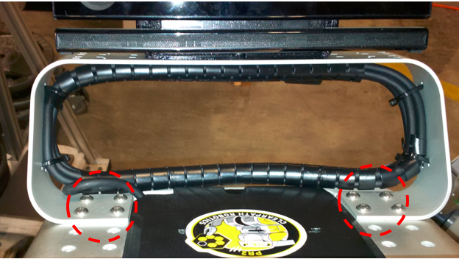
- Remove the top cap from the head and connect two power cables for Kinect and NUC to the side power distribution board:
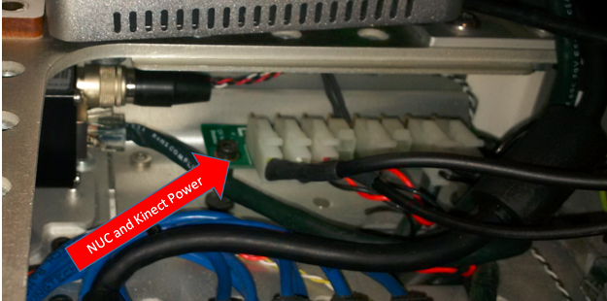

Assembly Instruction Page2

- Insert the Kinect Interface inside the head , push it behind the Cameras (Note , Picture taken from the back of the head)
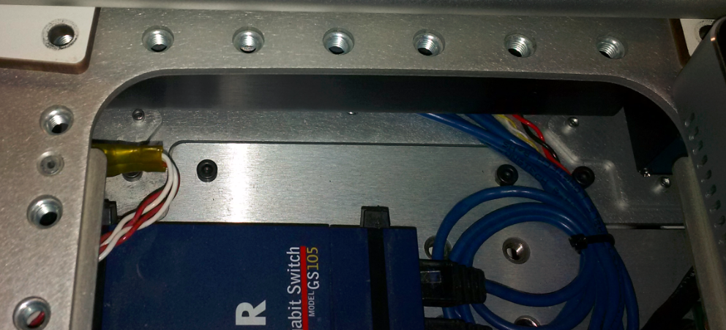
  - Connect the sensor cable from the right and USB3 and power from the left side
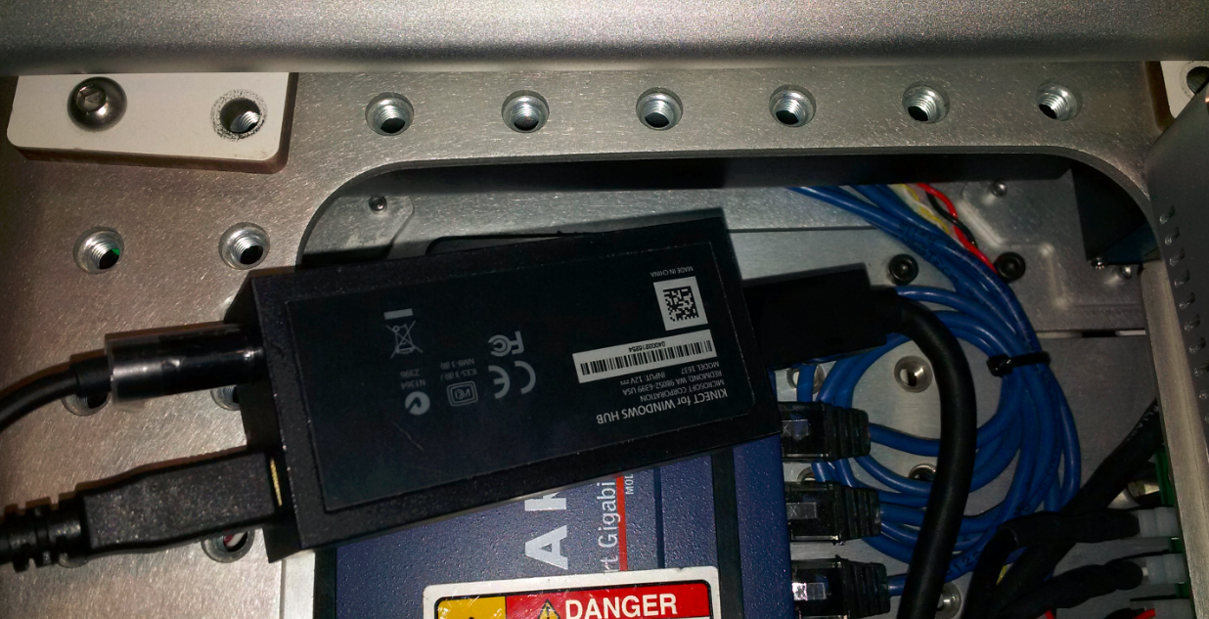

Assembly Instruction Page3
  - Place the interface inside the head :
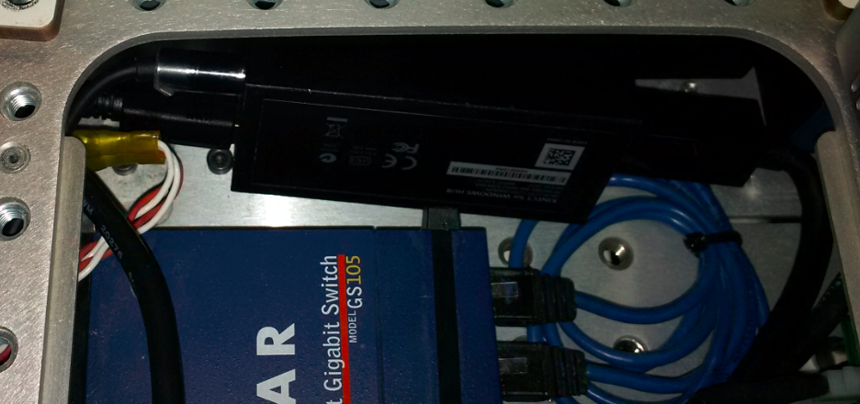
- Connect the USB3 cable from the sensor to Front and Power and Ethernet accessory cable in the head to the right side of the NUC
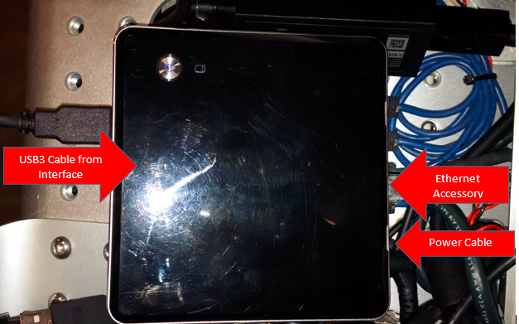

Assembly Instruction Page4

- Insert the NUC computer first from the USB side (NUC front):
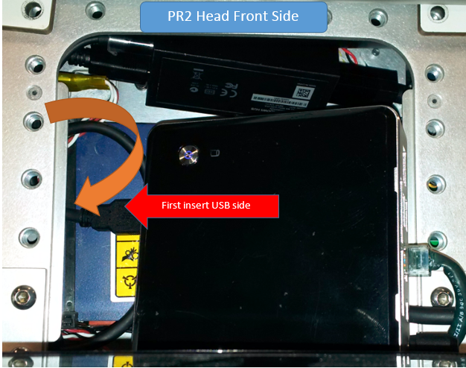

- Intel NUC should be place direct on the top of the Hub inside the head, if any wire or parts get between these two, top cap will not be able close properly.
- NUC completely placed inside the head and wired up:
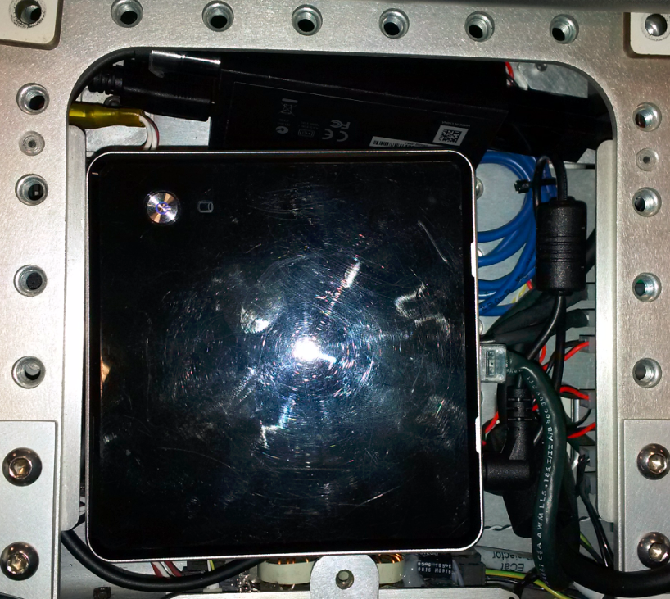

Assembly Instruction Page5

- Final step is to place the Cap and tight the M4 screw using 2.5mm bit with the 0.68Nm torque wrench:

